Date factory consist everything in the world of data.
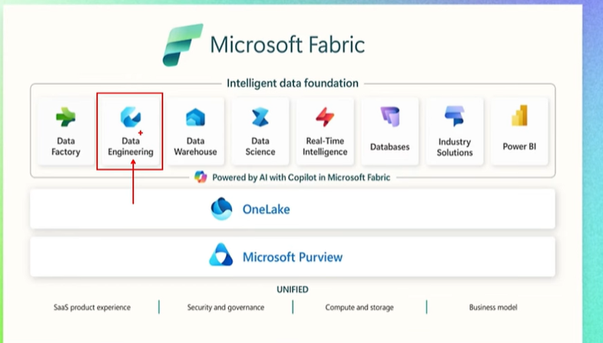
Need to understand difference between OneLake, Delta lake & DataLake
Fabric is a part of the Azure services.
How to create Azure free account:
- Search Azure Free account in google.
- Go to the Azure account creation and click on the Try Azure for Free
- After creating the azure account, go to the http://portal.azure.com/ page
- User: default mail, pass: short with b default then back count
- After providing the credential you will see the screen like below:
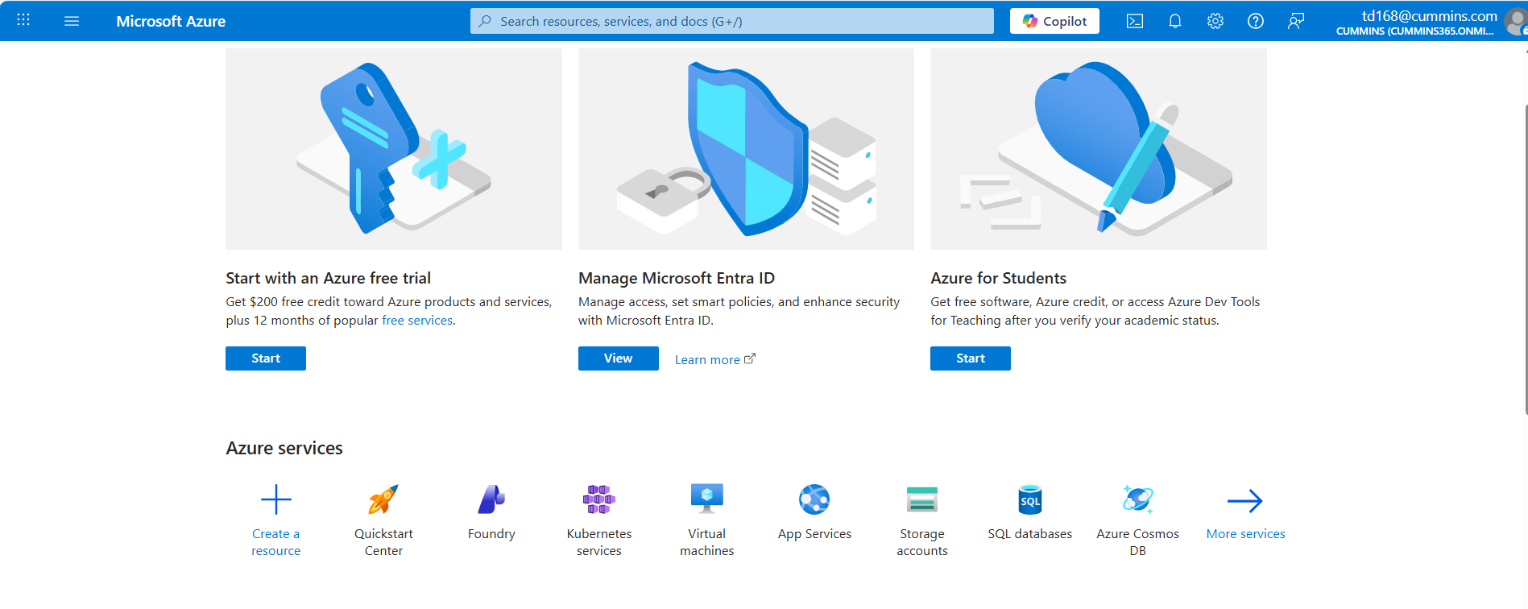
- Now to create Fabric account you can go to the Fabric and create the Fabric Capacity but its too costly to create. As we want free space to do tutorial on it, so Microsoft provide the 60 days trial period but for that you need organization domain account and we don’t have that.
- For that we need to go to the Microsoft Entra Id. This is the place where we manage users for a tenant.
- Microsoft Entra ID (formerly known as Azure Active Directory) is Microsoft’s cloud-based identity and access management (IAM) service. It is part of the Microsoft Entra product family, which focuses on securing identities and managing access across hybrid and multi-cloud environments.
- To create user go to the Manage Users New user
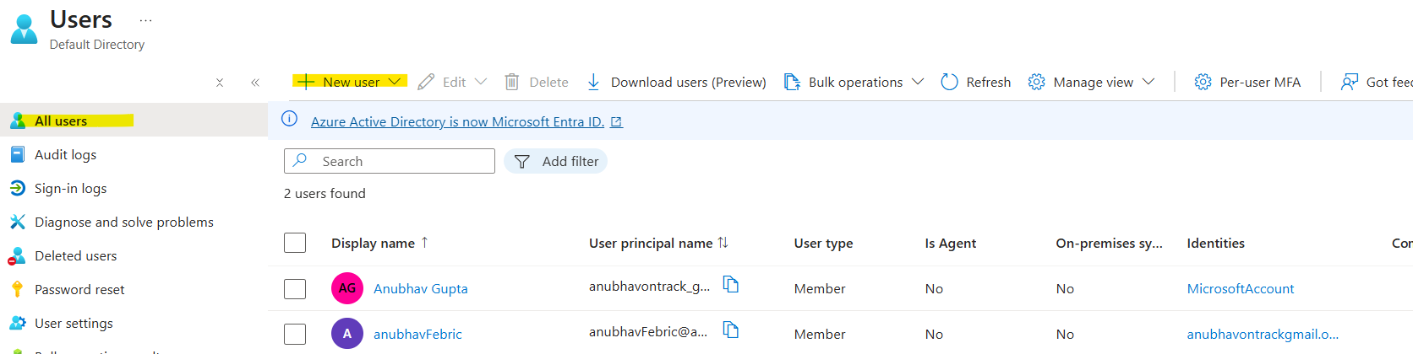
- Domain name came automatically as below, just needs to give principal name.
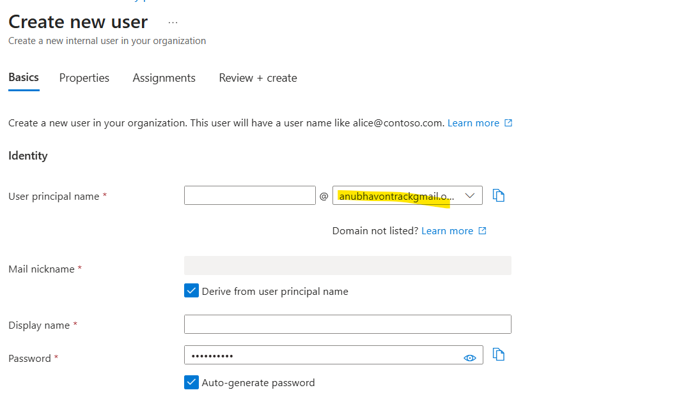
- Once user created then go to the http://app.fabric.microsoft.com/ url.
- Use your userid: fabricAcct@anubhavontrackgmail.onmicrosoft.com and pass: Default
- Once logged in page look like below:
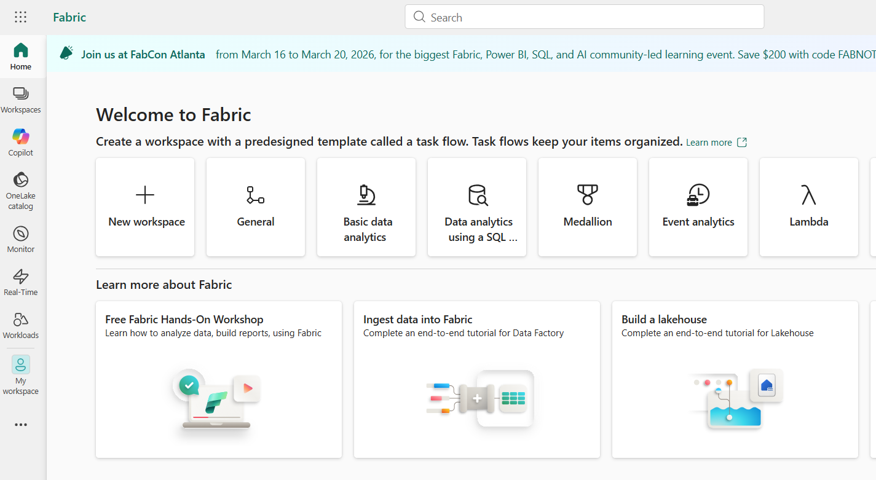
- Activate the free trail of Fabric by clicking on the User Icon Free trail Activate
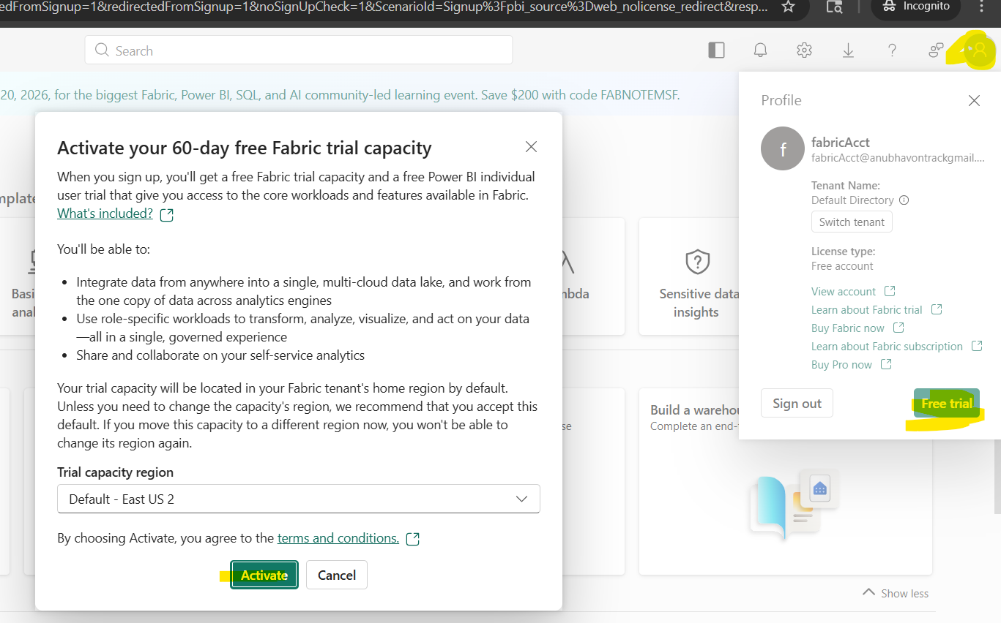

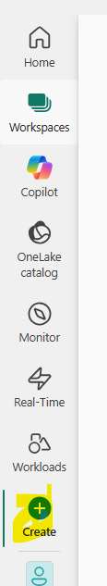
- Create is used to create anything related to fabric.
- Brouse button show resent created things.
- Monitor is to monitor
- GITHub: https://github.com/mails4anubhav/FabricWorkSpace
- U: mails P: default
Workspace
- Workspace: by default we get my workspace, which is default to your fabric.
- To create new workspaces, hit on the new workspace button, give the name of you workspace.
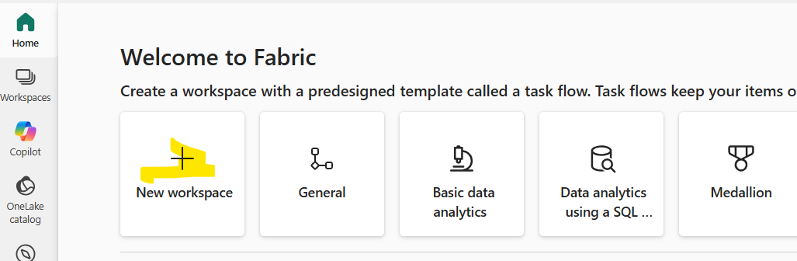
- We can create multiple workspaces within the Fabric capacity.
- And within the workspace we can create multiple items (Data flow, data pipeline, lake house etc..)

Items
Workspace
Fabric Capacity

- In a workspace there is a Manage Access button, which is used to give access on the workspace to the user. By default you are the admin of the workspace.
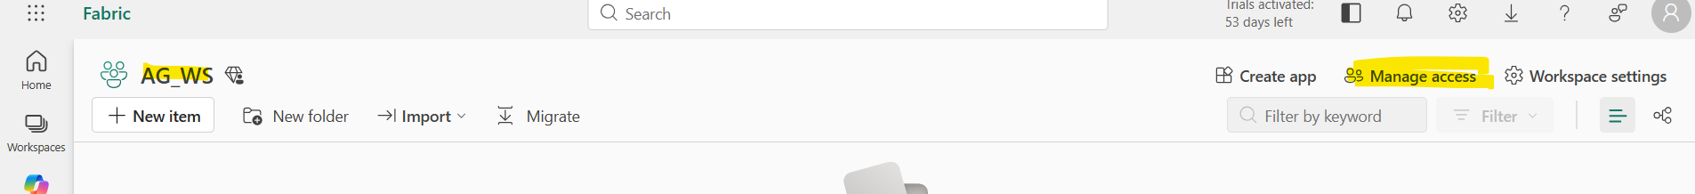
- There are four Roles of the user: Admin(access on whole Fabric capacity), Member( access Items within the workspace), Contributor and Viewer.
- Admin portal in the setting button is used to see the capacity of your Fabric Capacity, which means in which compute processing power you are using, by default it is F64 sku , it start form f32 to F512, it’s a package something which involved memory, ROM, Ram, processing power everything..
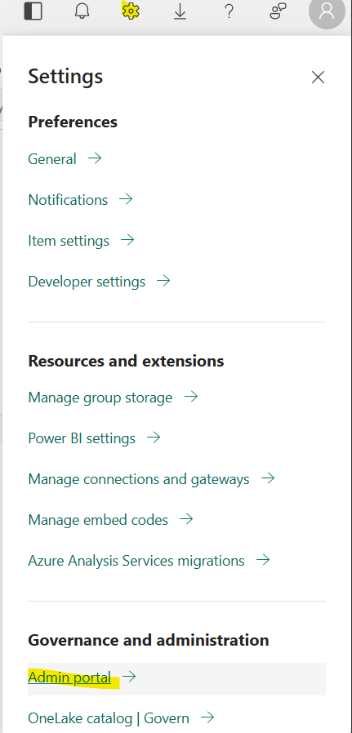
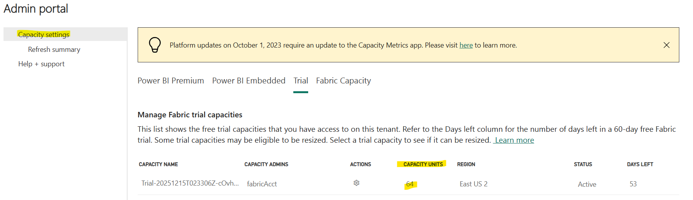

One Lake
- One lake built top of ADLS(Azure data lake), and One lake is a logical data lake.
- Fabric only have one lake only, within the One lake there could be multiple data lake.
- Its helps to bring all the data lake in one umbrella so that there will be no networking issue between the data lake and we can easily access each datalake.
- One copy of data: its mean we are ingesting data into One lake but we need to create separate copy of data for Finance team or any other team, so we just need to create Shortcuts for it. Its help to create logical copy of data in the data lake.
- We don’t need to create data lake as its already created with your Tenant account, which is your Azure account. That is why it is called as one drive of data.
Create LakeHouse
- Go to your Workspace and press New Item button then search Lakehouse.
- Table are created in the form of delta parquet file.
- Table, files all are saved in OneLake only.
- We can load the uploaded csv files data into the table format. Needs click on the three dots of the file to get the options as below:
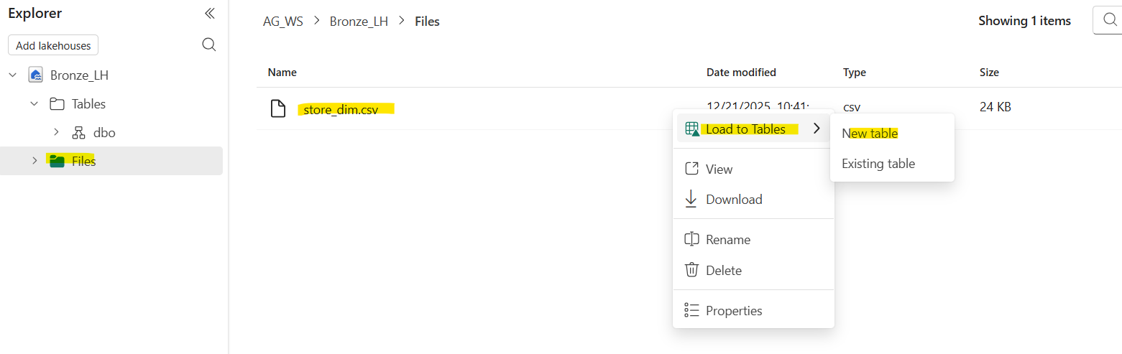
- To check the backend files of the table we just need to click on the three dot button of the table and see the files as below:
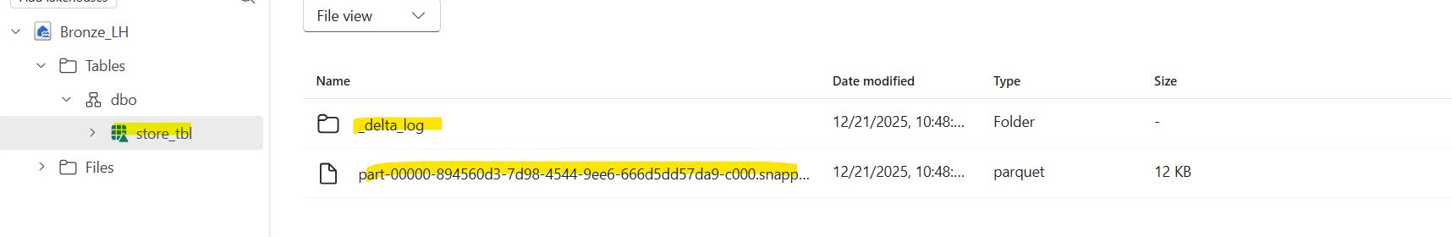
there are log file and Parquet file.
- So Delta table is a combination of log file and parquet file, Log files provide the ability of ACID properties to see the every change log in the table.

Create Pipeline
- Go to your workspace click on the new item and search for Data Pipeline.
- Give the name of the pipeline, then click on the Pipeline activity as below:
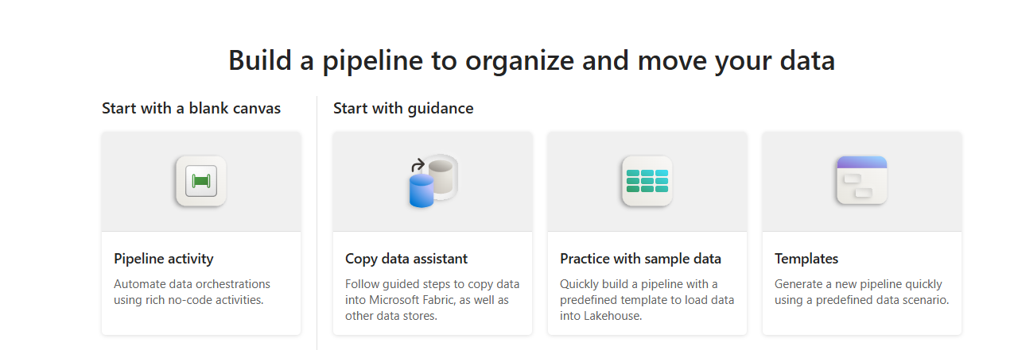
- In the activity option select copy data, it will open the canvas and which have all the option similar to the ETL tool,
Activity table have all the component witch help to move and transform the data.
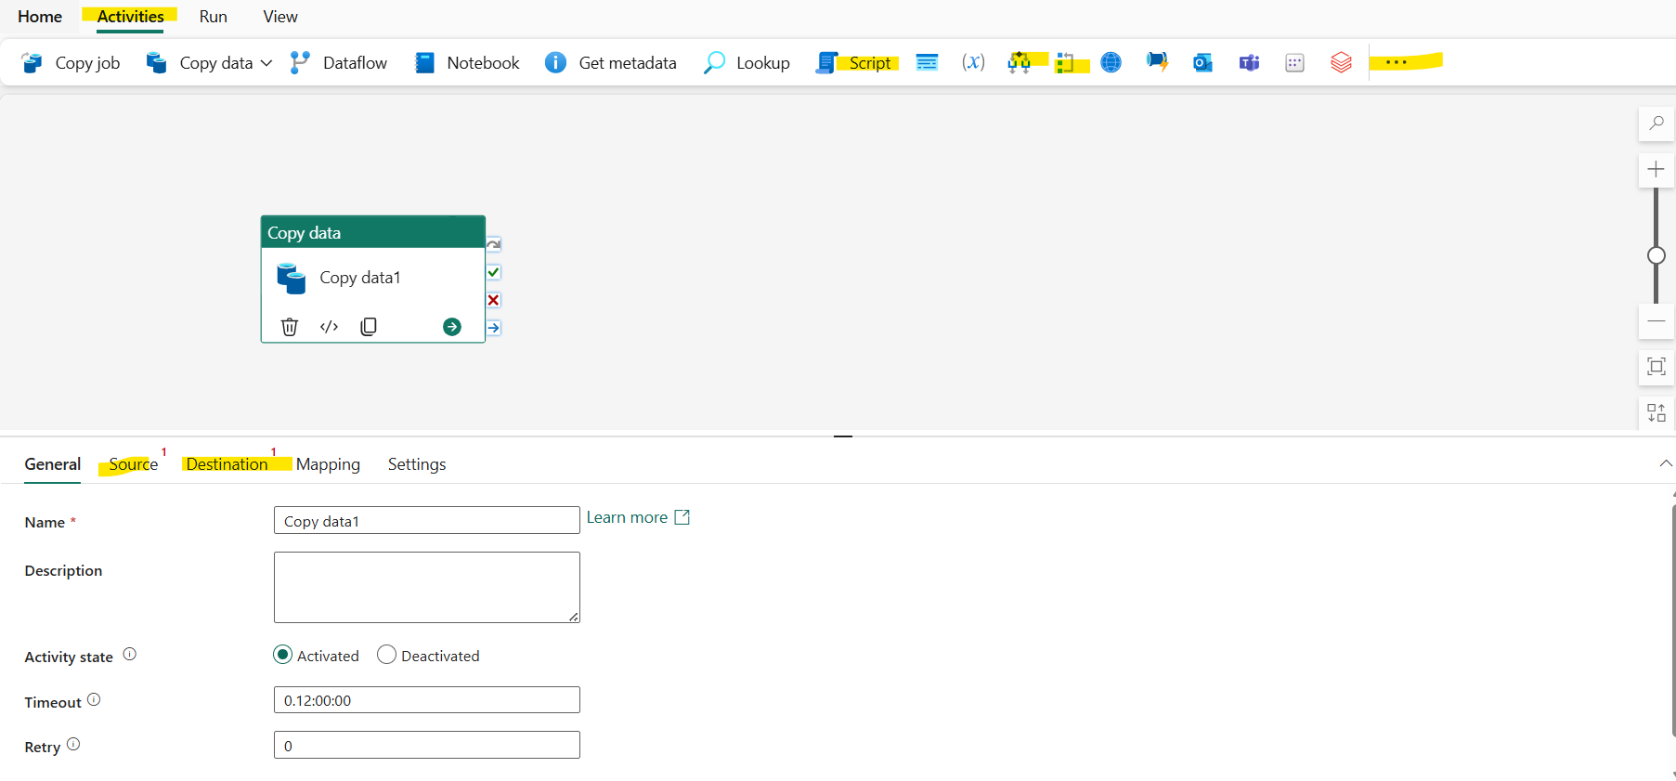
- Provide value in General tab like timeout and retry value as well.
- Select Source to select source, there are so many connector provided by the Fabric
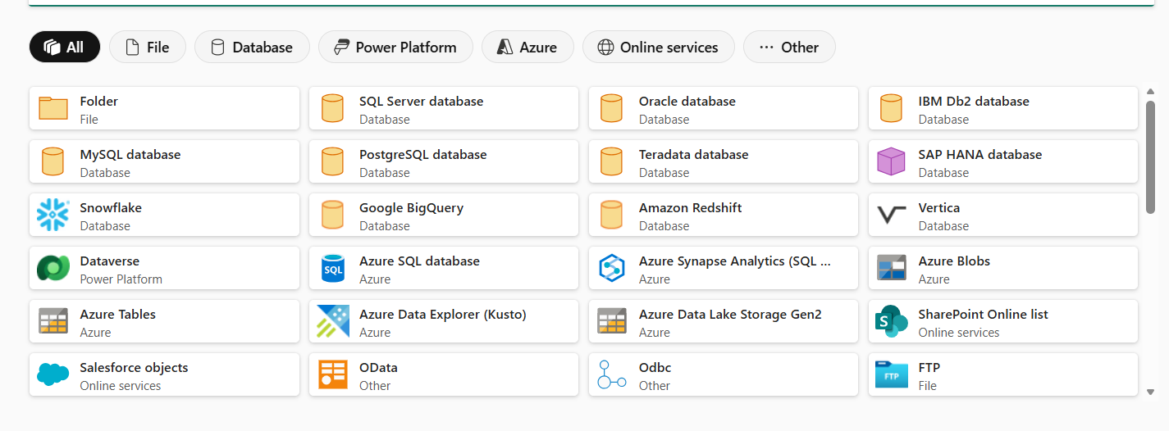
- To get the file data from the GitHub or any other file location use Http connection.
- Provide the raw path of the GithHub and create source connection,
- In destination need to add data into to LakeHouse table then provide below detail,
Select Lakehouse Select table Select Newgive name of the tableSelect append.
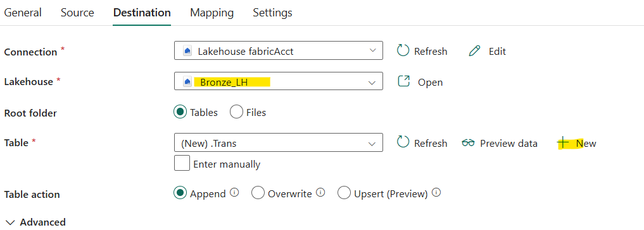
- In Advance option we can create partition of the table.
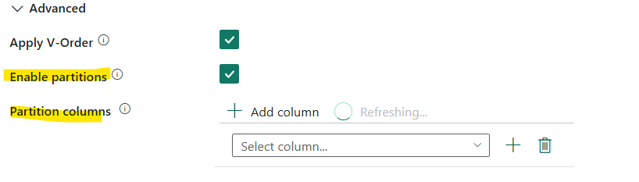
- After providing the destination click on the mapping tab to map the source to destination columns.
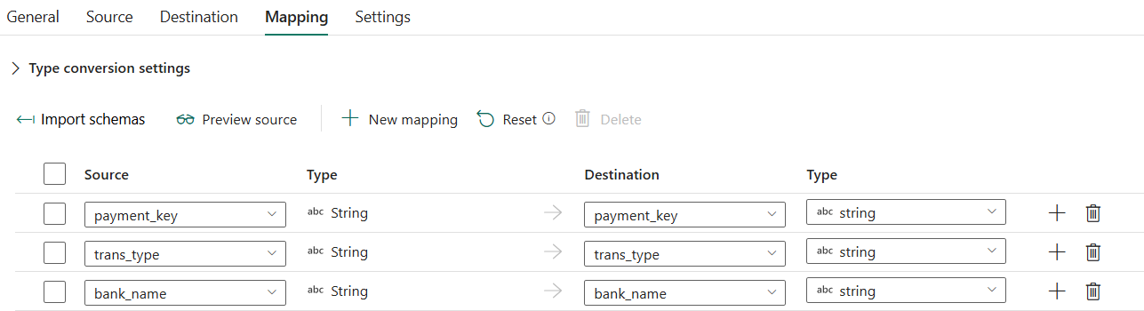
- Save the pipeline, validate and Run the pipeline to get the data.
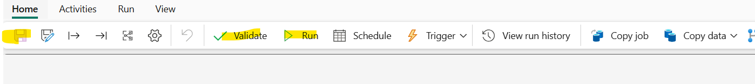
- Made Dynamic source connection, as earlier its stick to one file only. So we need to create the parameters for the file name as the source path is same just file name is changing. Click on the sourceAdd dynamic content
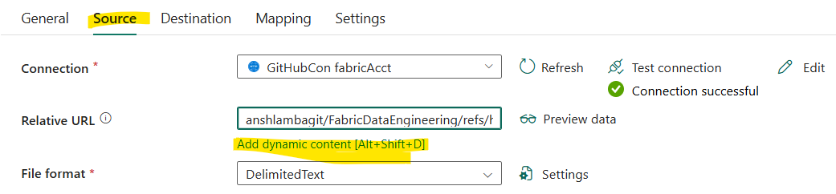
- Create Array type parameter to get the all the listed filename.
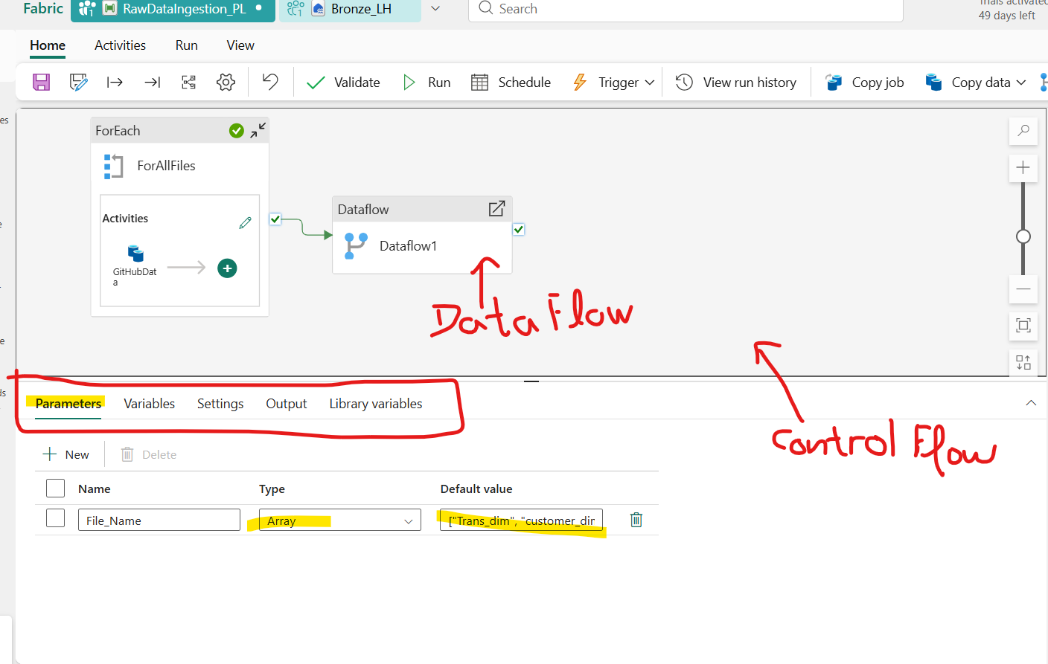
- Then use this parameter in the Items of ForEech loop container.
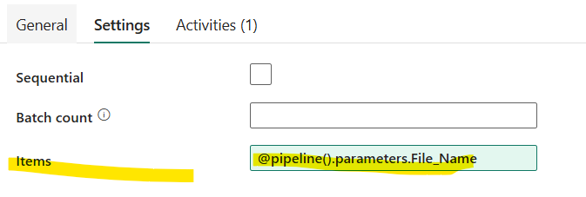
- In the CopyData container source tab use Item as parameter to made filepath dynamic:
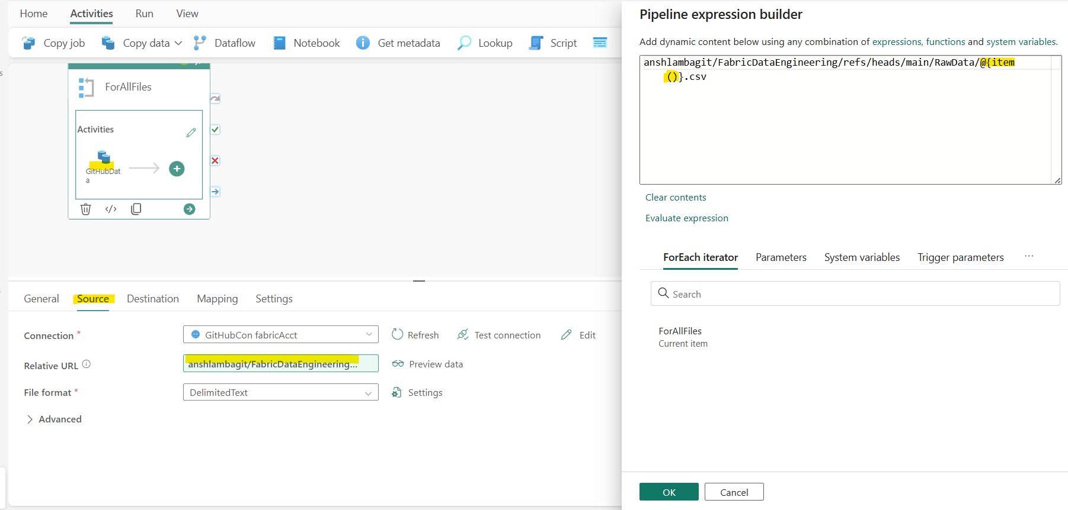

Monitor
- Monitor is used to see all the activity done on the fabric, for that we need to click on the Monitor button.
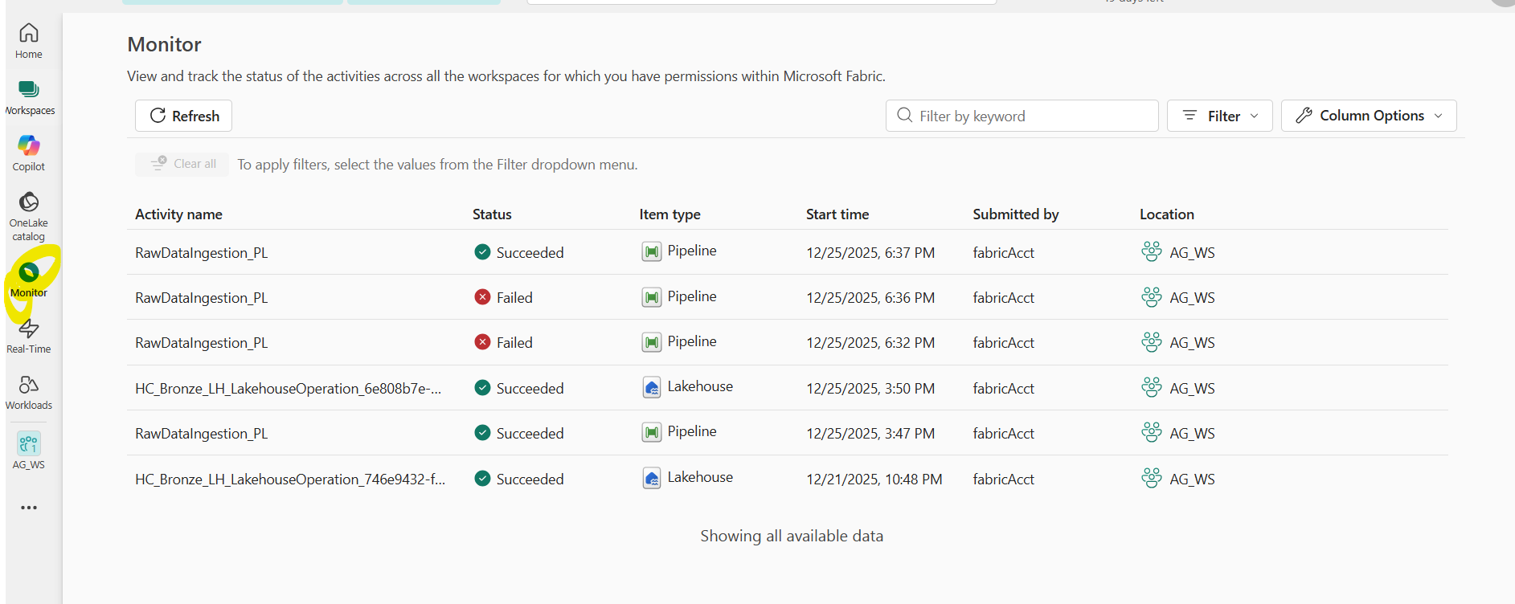

Shortcuts
- Short cuts are used in the Lakehouse to get the data form internal or external sources of data.
Its not copying the data its just a logical table/files in the lakehouse which link to the sources data.
- Following are the step to create shortcut from one Lakehouse to another lakehouse internally.
- Click on the three dots of the file and select create shortcuts:
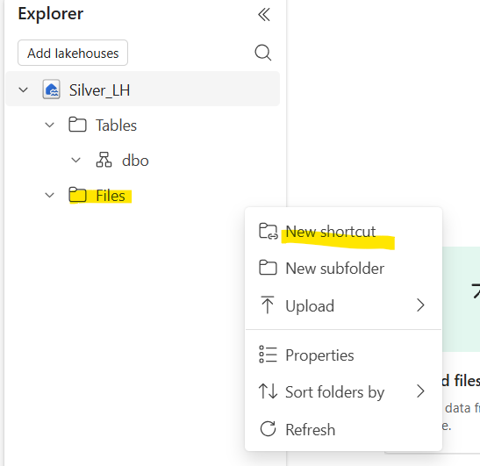
- It will show internal and external sources: Select internal source for now:
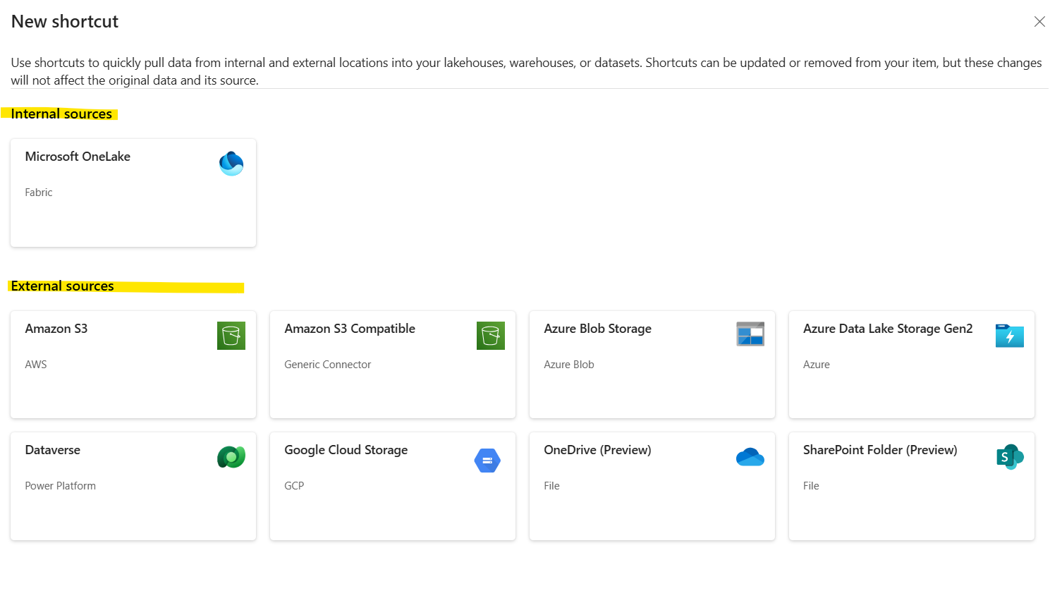
- Select the path from where you want to create the shotcuts
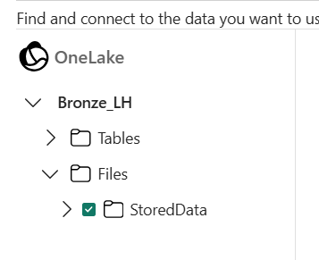
- Give the name of the short cut and it will create the shortcut.
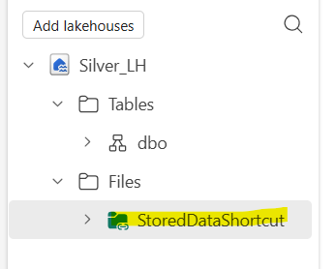

NoteBook
- Go to workspace Add item search Notebook and create.
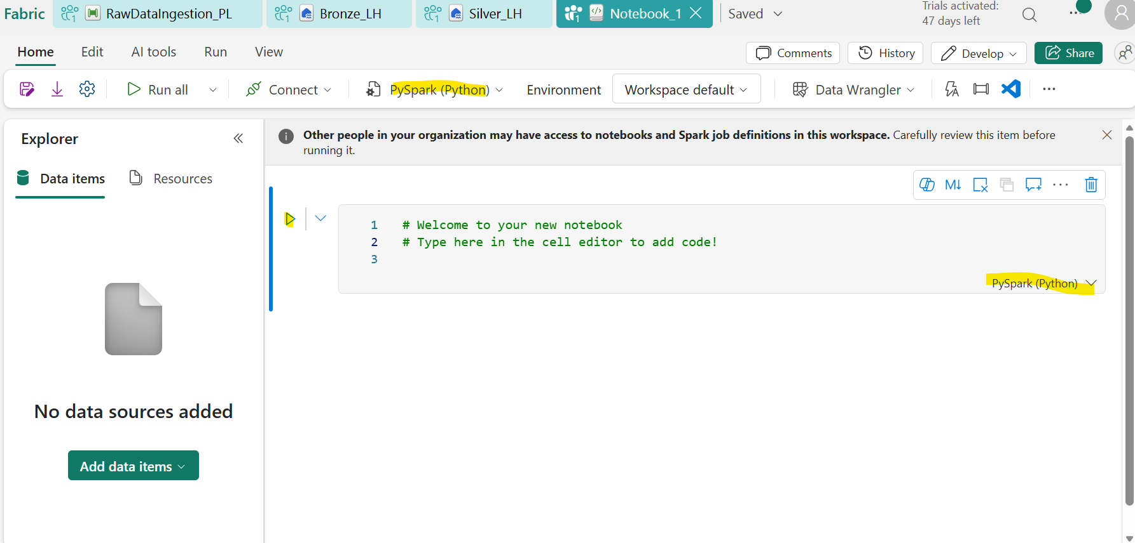

- Markdown cell is to define heading or details of the notebook, so that we can get the details of the notebook.
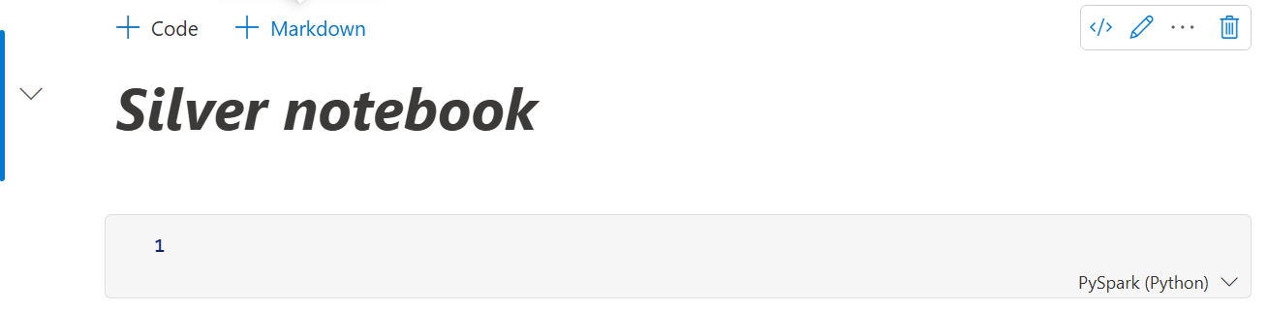
- To link the notebook with Lake house need to click on the Add data items in Data items section:
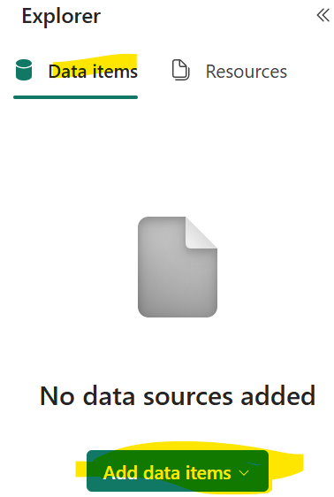
- NotebookUtils: Microsoft Fabric includes a built-in utility package called NotebookUtils (formerly mssparkutils), designed for use within Fabric Notebooks (PySpark, Scala, SparkR) and supported in Fabric Data Pipelines. It streamlines common tasks such as managing file systems, running notebooks, handling secrets, working with user-defined functions, and managing notebook artifacts. citeturn3search1turn3search..
Key Features of NotebookUtils
- File System Utilities (notebookutils.fs)
- List directory contents, copy, move, delete files and directories across ADLS Gen2, Blob, OneLake, or local file systems (ls, cp, mv, rm, etc.).
- Fast transfers using fastcp via AzCopy for large datasets.
- Create directories (mkdirs); write, append, or preview file contents (put, append, head).
- Mount/unmount external storage paths for seamless access.
These methods are useful for organizing data within notebooks and pipelines.
- notebookutils.fs.ls("Files") : Is used to get the list of files with in the lakehouse connected with the notebook.
- notebookutils.fs.cp(): is used to copy file from source to destination.
- PySpark(python) code to read the file data siting in the linked lakehouse
df = spark.read.format("csv")\
.option("Header",True)\
.option("inferSchema",True)\
.load("Files/StoredDataShortcut")
- To see data in Df : display(df)
- PySpark(python) code to read the Delta table data from different lakehouse
- Copy ABFS path from the Delta table: Press three dots of the table Property copy ABFS path
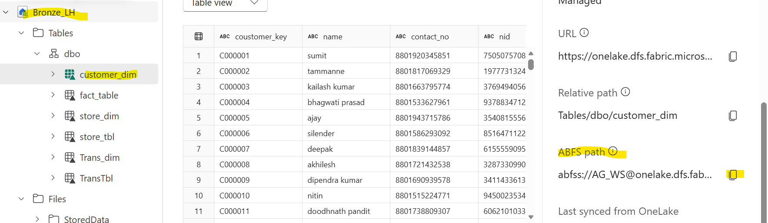
- spark.read.format("Delta").load("abfss://AG_WS@onelake.dfs.fabric.microsoft.com/Bronze_LH.Lakehouse/Tables/dbo/customer_dim")
- Read the data directly from the table:
df_cust = spark.read.table("Bronze_LH.dbo.Customer_dim")
display(df_cust)
- Add library in notebook to support various inbuilt function:
from pyspark.sql.functions import *
from pyspark.sql.types import *

- Modify column value and add new column
display(df_cust.withColumn("firstName",split(col('name'),' ')[0])\
.withColumn("LastName",split(col('name'),' ')[1]))

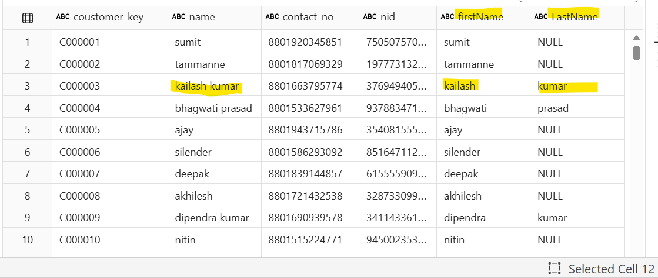
- Replace null with NA : df_cust = df_cust.fillna({"LastName":"NA"})

Managed table VS External Table

- Managed table: are the delta table created under table section, where metadata and the data are stored and managed by the lake house, if we drop the table metadata and the data file both dropped together.
Code to write data into the manage table:
df_cust
df_cust.write.format("delta")\
.mode("overwrite")\
.saveAsTable("Silver_LH.dbo.CustomerDim")

- External table: are the table where metadata reside on the table section and the data of the table are stored in the files section.
Advantage of this table if we drop the table, it just drop the metadata of the table but data will be present in the files, and also we can save the data file in any other lakehouse as well.
Following is the code to create external table from the dataset (df_cust)

df_cust.write.format("delta")\
.mode("overwrite")\
.option("path","abfss://AG_WS@onelake.dfs.fabric.microsoft.com/Silver_LH.Lakehouse/Files/ExternalTables")\
.saveAsTable("Silver_LH.dbo.ExtTable")
- To create external table, code should have Path .option("path","
- To get the path where you want to create the external table file need to click on the three dots of the file path example below:
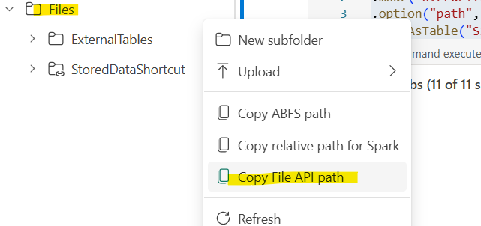
- After running the code it will create the table metadata file in the table section and data file in the Files section
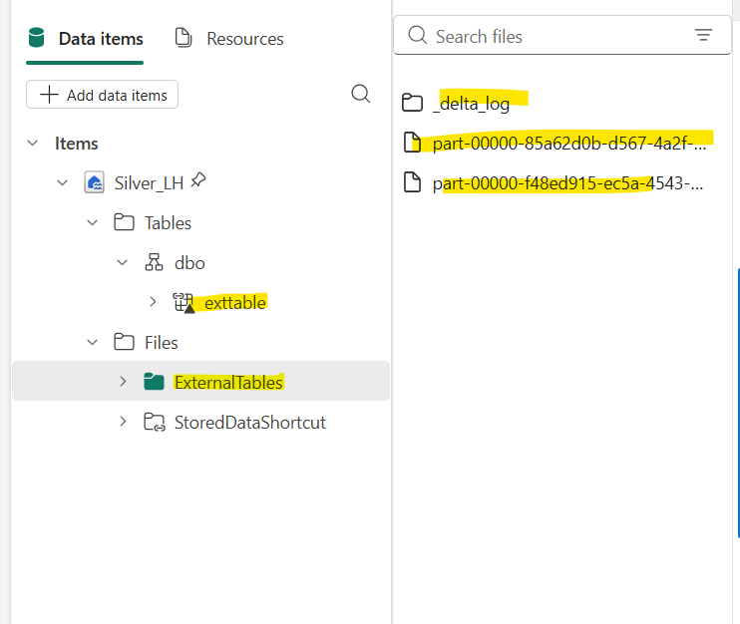
- We can give file path to any other Lakehouse as well if you want to save the data into any other lakehouse.
- There are four types of mode:
- Overwrite: overwrite the existing file, and write
- Append: Append data in the existing file.
- Error: Throw error if file exist
- Ignore: DO nothing

NoteBook some more codes to manipulate data

- Change the data type of the column
df_Fact = spark.read.table("Bronze_LH.dbo.Fact_Table")
df_Fact = df_Fact.withColumn("quantity", col("quantity").cast(IntegerType()))\
.withColumn("unit_price", col("unit_price").cast(IntegerType()))\
.withColumn("total_price", col("total_price").cast(IntegerType()))
df_Fact.printSchema()
- You can create chart top of the data, it is to validate and visualize the data
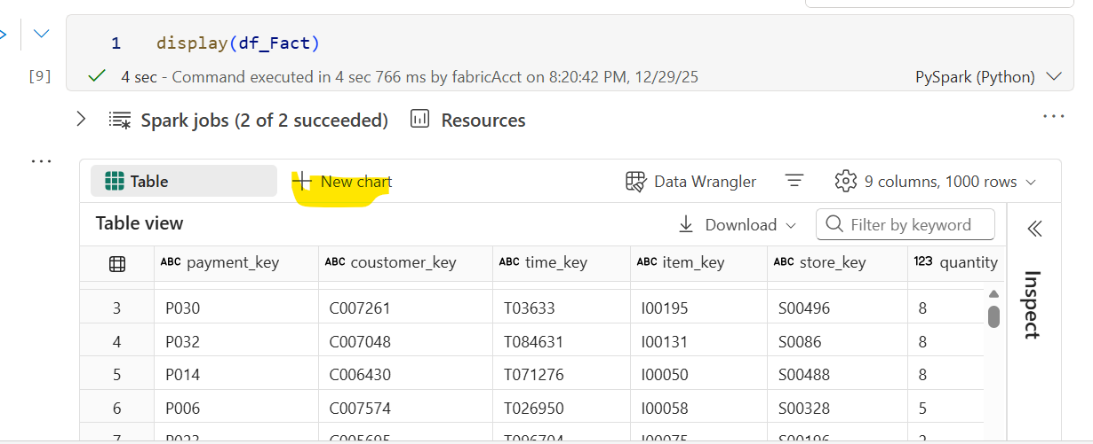
- Concat and drop column
df_store = df_store.withColumn("address",concat(col("district"),lit("-"), col("Upazila")) )
df_store = df_store.drop("district", "upazila")

- Replace string:
df_tran = df_tran.withColumn("bank_name",regexp_replace("bank_name","None", "Not Available"))

Warehouse
- To create warehouse go to workspace and add new item as warehouse, provide name of the warehouse.
- Create new schema, in the warehouse
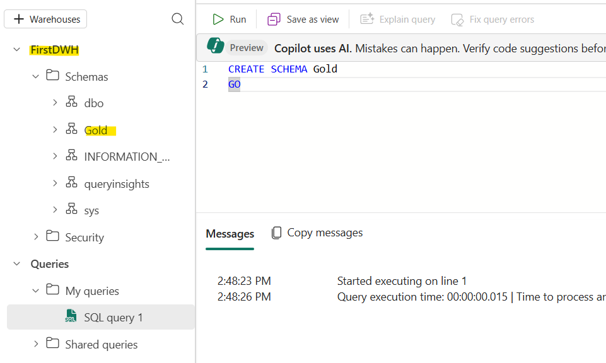
- CTAS (Create table as select): create table from the lakehouse.

On-Premises Data Gateway
- To connect on premise SQL server we need to install the on premises data gateway into the system which have sql server intalled.
- Microsoft Download Center – On-Premises Data Gateway
https://www.microsoft.com/en-us/download/details.aspx?id=53127
- After downloading and installing needs to stetup it with Fabric account and password.
- Sign in with your work Entra ID account and configure a recovery key.
- After setup in the local pc go to the Fabric account setting Manage connections and gateways
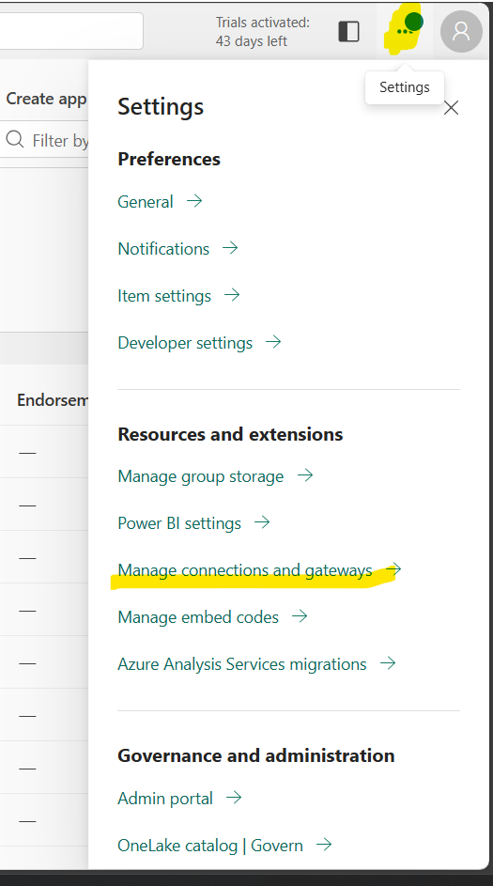
- Then click on the new to create new connection
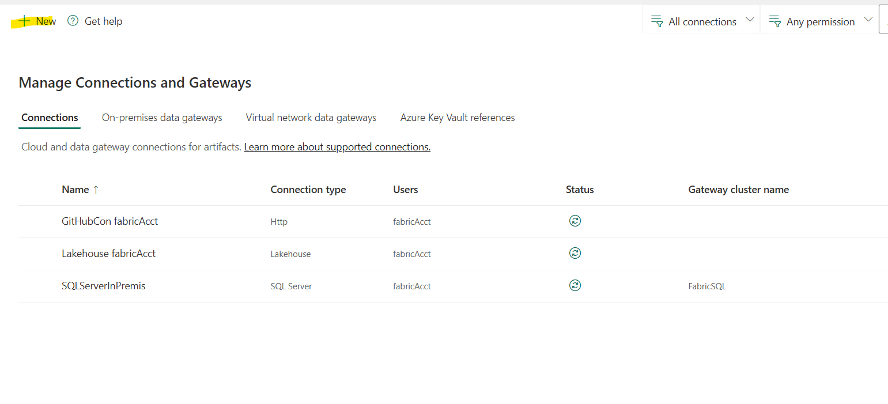
- Provide following highlighted details:
Gateway cluster name: will appear same automatically in dropdown which was given during gateway setup in your local PC.
Connection Type: select sql server from the list.
Server: Provide same server name of SQL Server
Database: same name of the DB
Authentication Method: select Basic
Then user password of the SQL Server.

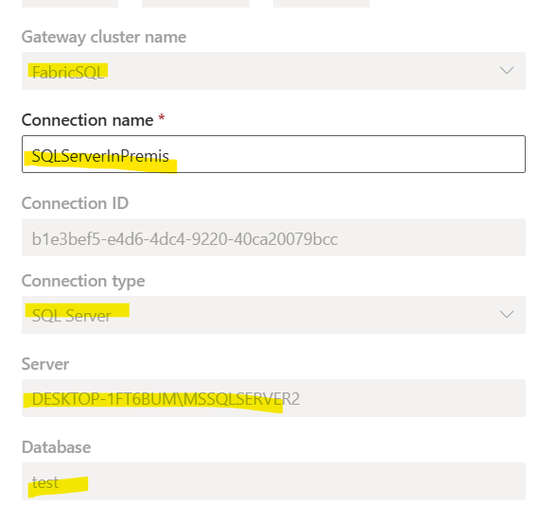
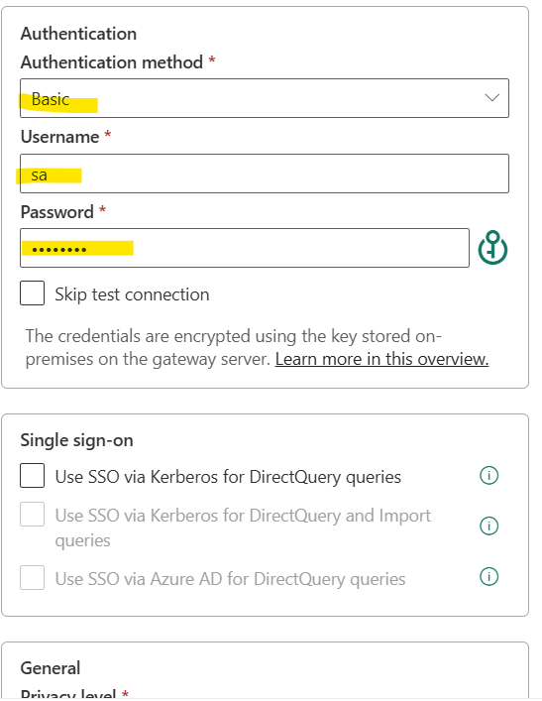
Profisee Master data management tool
Profisee has built a native Master Data Management (MDM) experience right inside Microsoft Fabric.
That means you can:
- Define MDM entities
- Match/Merge/Cleanse data
- Do data stewardship
- Publish trusted master records
…all within the Fabric UI without switching tools. Profisee
This is similar to having MDM as a first-class workload in Fabric rather than integrating a separate system.

Where Profisee Runs & Licensing Context
✔ Profisee within Fabric capacity
- When you add the Profisee MDM workload to a workspace, you must assign it to a Fabric Premium capacity. Profisee
- This means the MDM workload runs on your Fabric infrastructure/capacity, blending directly with your data ecosystem rather than a separate service you call externally.
In other words:
Profisee MDM in Fabric runs under your Fabric premium capacity, not outside in some separate environment.

